Active House

By: Oliver Duarte, Kyle Sy, & Vishwas Malhotra

Discipline: Computer Engineering Technology

Date: April 23, 2018

Declaration of Joint Authorship
We of Active House, Oliver Duarte, Vishwas Malhotra, and Kyle Sy confirm that this work submitted for assessment is the joint work of ourselves, and is expressed in our own words. Any uses made within of other works of any other author, in any form (ideas, equations, figures, previous technologies, tables, programs, texts) are properly acknowledged at the point of use. A list of the references used is included. Oliver Duarte has handled the mobile application, as well as aided in the creation of the database and web service. Vishwas Malhotra has handled the hardware, as well as the interaction between hardware and the database. Kyle Sy has handled the database.

Approved Proposal

Executive Summary
As a student in the Computer Engineering Technology program, we will be integrating the knowledge and skills we have learned from our program into this Internet of Things themed capstone project. This proposal requests the approval to build the hardware portion that will connect to a database as well as to a mobile device application. The internet connected hardware will include a custom PCB with the following sensors and actuators luminosity sensors, gas sensors, temperature sensors, current sensors, water flow sensors. The database will store log in credentials and data picked gathered by the sensors. The mobile device functionality is to show the data from the database in the app and will be further detailed in the mobile application proposal. We will be collaborating with no department or company. In the winter semester we plan to form a group. Our group includes Vishwas Malhotra and Oliver Duarte and Kyle Sy. The hardware will be completed in CENG 317 Hardware Production Techniques independently and the application will be completed in CENG 319 Software Project. These will be integrated together in the subsequent term in CENG 355 Computer Systems Project as a member of a 3 student group.

Background
The problem that our project solves revolves entirely inside a room. Due to errands we have to attend to, we are forced to leave the comforts of our room. While this project doesn’t allow users to attend to their agendas without leaving their rooms; it brings their rooms with them so they won’t have to worry what’s going on inside their rooms-- to some extent.. A bit of background about this topic is that this project is a collection of sensors that will allow the user to pickup different elements inside a room. It was inspired by having the issue of being away from your room and wanting to monitor it. This is a sophisticated system that includes a raspberry pi and arduino. The communication between the arduino and the raspberry pi occurs with two xbee shields attached to the arduino and the pi. The sensors include: lux sensors which is used to measure the luminosity, water flow sensor which measures the volume of water in liters per second, gas sensors which detects different kinds of gasses in the room, temperature sensor which measures the temperature in any temperature based unit of measurement, current sensors which measures current in amperes..
Existing products on the market include [1]. I have searched for prior art via Humber’s IEEE subscription selecting “My Subscribed Content”[2] and have found and read [3] which provides insight into similar efforts.
In the Computer Engineering Technology program we have learned about the following topics from the respective relevant courses:
- Java Docs from CENG 212 Programming Techniques In Java,
- Construction of circuits from CENG 215 Digital And Interfacing Systems,
- Rapid application development and Gantt charts from CENG 216 Intro to Software Engineering,
- Micro computing from CENG 252 Embedded Systems,
- SQL from CENG 254 Database With Java,
- Web access of databases from CENG 256 Internet Scripting; and,
- Wireless protocols such as 802.11 from TECH152 Telecom Networks.
This knowledge and skill set will enable me to build the subsystems and integrate them together as my capstone project.

Methodology
This proposal is assigned in the first week of class and is due at the beginning of class in the second week of the fall semester. My coursework will focus on the first two of the 3 phases of this project:
Phase 1 Hardware build.
Phase 2 System integration.
Phase 3 Demonstration to future employers.
Phase 1 Hardware build
The hardware build will be completed in the fall term. It will fit within the CENG Project maximum dimensions of 12 13/16" x 6" x 2 7/8" (32.5cm x 15.25cm x 7.25cm) which represents the space below the tray in the parts kit. The highest AC voltage that will be used is 16Vrms from a wall adaptor from which +/- 15V or as high as 45 VDC can be obtained. Maximum power consumption will be 20 Watts.

Phase 2 System integration
The system integration will be completed in the fall term.
Phase 3 Demonstration to future employers

This project will showcase the knowledge and skills that I have learned to potential employers.

The brief description below provides rough effort and non-labour estimates respectively for each phase. A Gantt chart will be added by week 3 to provide more project schedule details and a more complete budget will be added by week 4. It is important to start tasks as soon as possible to be able to meet deadlines.
The purchases for this project includes a raspberry pi, the sensors mentioned above and arduino which total to $300.00

Concluding remarks
This proposal presents a plan for providing an IoT solution for The sensors will be attached to arduino as a PCB hat and the arduino will post the gathered data to a firebase database which will then be used to update the mobile application.. This is an opportunity to integrate the knowledge and skills developed in our program to create a collaborative IoT capstone project demonstrating my ability to learn how to support projects such as the initiative described by [3]. I request approval of this project.

References
[1] none
[2] Institute of Electrical and Electronics Engineers. (2015, August 28). IEEE Xplore Digital Library [Online]. Available: https://ieeexplore.ieee.org/search/advsearch.jsp
[3] none

Abstract
The Active House home monitoring system that utilizes a variety of sensors. These sensors are apart of a sensor hub that is combined with an arduino to send data to a raspberry pi base station, which will then send it to a database, which will then be able to be accessed on a mobile application. The sensors will store and send data on temperature, humidity, lumosity, smoke and gas detection, water consumption, and power consumption. It will buzz when CO levels reach dangerous levels as a safety feature as well. This system will allow the user to keep these measurements in check on the go. The mobile application will display the most recent sensor data to the user. This data can be displayed and singled out for each individual room that is connected to the raspberry pi base station. This system allows users to have an overview of their home when they are not around, and also allows them to be safe at home with the gas detection, provided they have an internet connection.

Table of Contents
Declaration of Joint Authorship 2
Approved Proposal 3
Abstract 3
Illustration List 6
1. Introduction 6
2. Project Description 6
2.1 Problem 6
2.2 Rationale Behind Project 6
2.3 Project Scope 6
2.4 Software Requirement Specifications 6
2.4.1 Database 6
2.4.2 Mobile Application 7
2.4.3 Web Service 8
2.4.4 Raspberry Pi Base Station 9
2.4.5 Sensor Hub 9
2.5 Project Overview 10
2.5.1 Bill of Materials 10
2.5.2 Time Commitment 10
2.5.3 Mechanical Assembly 10
2.5.4 PCB and Soldering 10
2.5.5 Power Up 10
2.5.6 Unit Testing 10
2.5.7 Production Testing 10
2.6 Problems Encountered 10
3. Progress Reports 11
3.1 Report 1 11
3.2 Report 2 11
3.3 Report 3 11
4. Conclusions 11
5. Recommendations 11
6. Technical References 11
7. Appendicies 11
7.1 Arduino Uno Sensor Setup 11
7.2 Arduino Xbee link 11
7.3 Database Code 11
7.4 Mobile Application 11
7.4.1 Main Activity 11
7.4.2 RoomActivity 11
7.4.3 RoomViewActivity 11
7.4.4 HomeActivity 11
7.4.5 Register Activity 11

Illustration List

1. Introduction
The Active House project is a home monitoring system which utilizes a variety of arduino sensors, which are apart of our sensor hat, and sends data to our raspberry pi base station which will handle sending data to our database to allow data transfer from the arduino to our mobile application. The sensor hub has a variety of sensors such as: temperature, humidity, lumosity, smoke and gas detection, water consumption, and power consumption. The water and power consumption sensors are detachable since they will not be used in every room. The mobile application allows users to toggle their lights, set a lighing schedule, as well as view data from the sensors for each room.
Our system will store our data using a php handled mysql database located off-site. It will be hosted by Hostinger.com, a third-party site. It can be accessed via mobile application and web interface, providing off-site monitoring of the user's home. The home owner will be able to make sure that their home is safe and that nothing inside is getting too out of hand.

2. Project Description

2.1 Problem
Real-time home monitoring is exclusive for those who can afford expensive housing. The general public does not have the means to be able to go and spend thousands of dollars on devices to check their average day's worth of energy usage, as well as checking how temperature, humidity, and light are affecting each room in their home.

2.2 Rationale Behind Project
In order to solve this problem, this real-time, small-scale, home monitoring system was devised. This system will allow users to store and view data with accuracy where each of the nodes are installed. It will be a replacement for a larger, more expensive system of which many cannot afford.

2.3 Project Scope

2.4 Software Requirement Specifications

2.4.1 Database

There is a database being hosted on hostinger.com. This database will store the data for each of the sensors in the sensor hub. It will store the data for temperature, humidity, lux, water usage, power usage, and CO levels. This data will be stored in a room which will be retrieved from the DB and displayed in the mobile application. The database will have the following tables: Blah Blah Blah Blah.

Work Breakdown:
The database needs to be reconfigured to allow application access to it. This will be done by both Oliver and Kyle.

2.4.2 Mobile Application

There will be a mobile application (currently only available on Android platforms) which will take formatted data from the database and display it in a simple manner. The application will utilize the data from the database to allow users to view data on: temperature, humidity, water usage, power usage, light, and CO levels. The application will call for updates each time the user refreshes the page, or loads the application. This data will be displayed for the overall house.

MainActivity: This activity is the main page of the application after logging in. This page will be displaying the data pulled from the database. It will display the temperature, humidity, water usage, power usage, light, and CO levels of the room where the sensor hub is stored.

Register: Accessible from the login screen. Utilizes EditText fields for users to enter their information. The user will be prompted to enter a username, email, and password. This will be entered into the database of which the user can use as login credentials.

Login: The screen seen upon bootup of the application. This screen prompts the user to enter their login information. If the fields are not filled in, the application will return a message saying there has been an error. If it succeeds, the app will return success.

(Developed by Oliver Duarte)

Work Breakdown:
Adjustments to the application is needed.

2.4.3 Web Service

Our project has a software system design that will facilitate the transfer of data between a gateway and a database. This is our blueprint for a support for a machine-to-machine interaction over a network. Basically, the raspberry pi will be a communicating medium between the arduino which is our sensorhub/sensorbox and the database through a worldwide service. This service will be utilized for communication purposes, specifically for transferring machine readable files. We will have a database server which will be utilized by a mobile application.

This will be finished by Kyle Sy.

2.4.4 Raspberry Pi Base Station
The Raspberry PI base station is used to communicate with the sensor hubs over Xbee serial communication to gather all of the sensor data and send it to the web service.
(Group Effort)
Work Breakdown:
The work remaining on the base station is to receive data from the sensor hub, then being able to upload it to the cloud. It will require PHP coding to send data to the database. This will be done by Vishwas.

2.4.5 Sensor Hub
The sensor hub requires the arduino to communicate with the Base station over Xbee Serial Communication to send the sensor data as well as toggling the light status.
(Written by Vishwas Malhotra)
Work Breakdown
The work that needs to be done is soldering the rest of the sensor components for the sensor hub, as well as coding the Arduino to send sensor data over xbee serial connection to the base station. This will be finished by Vishwas.
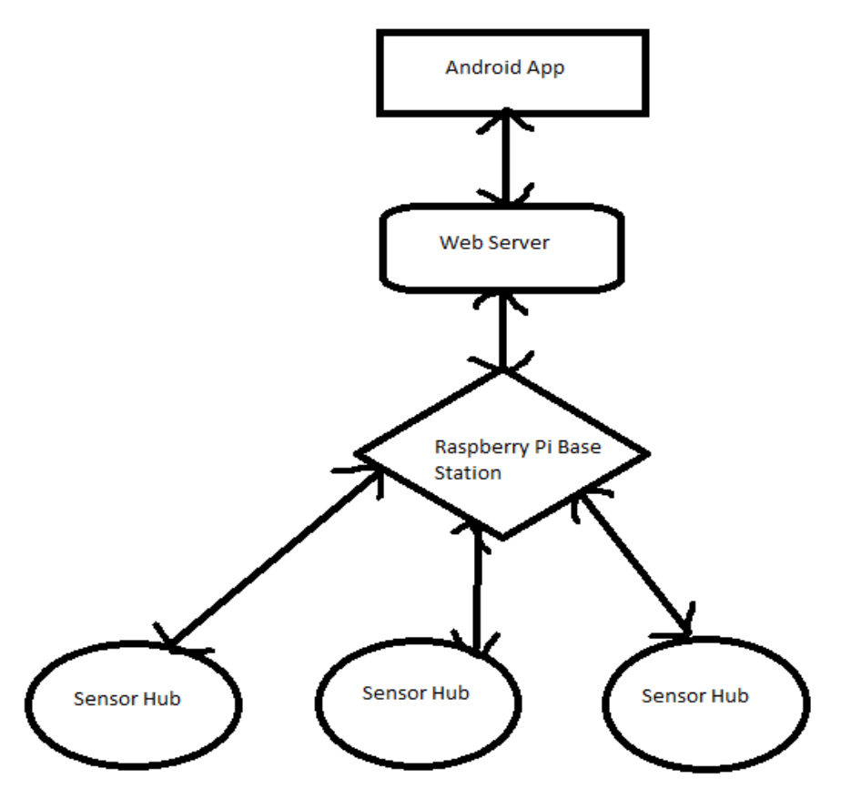

2.5 Project Overview

2.5.1 Bill of Materials
Parts Needed:
- Raspberry Pi model 2(or 3) with Power Source and Raspbian installed
- Arduino Uno Smd with Power Source
- CEM-1203(42) Alarm
- Adafruit MICS5524 CO Gas Sensor Breakout
- Adafruit TSL2561 Digital Light Sensor Breakout
- Adafruit SHT31-D Temperature & Humidity Sensor Breakout
- G1&2" Water Flow Sensor
- Non-Invasive Current Sensor - 30A
- ArduinoXBee Shield v1.1
- 2 Digi XBee S1
- SparkFun XBee Explorer Dongle
- Wires
- Breadboard

2.5.2 Time Commitment
The Active House project with a complete set of code will require approximately 5-8 hours to solder and have running. There will be small issues with soldering as the pcbs that are designed are particularily difficult to solder. Any slight mistake will render the board useless, thus perfection is required. This would be for someone with a decent understanding of php, android, arduino, and python coding, as well as experience in soldering. For someone who doesn't have an extensive knowledge in all of these areas, and wish to reproduce majority of the project on their own, it may take a lot longer.

2.5.3 Mechanical Assembly

Build Instructions

The active house is a simple buildable project that allows someone to monitor the rooms in their house or office with the active house app.

Building Breadboard:
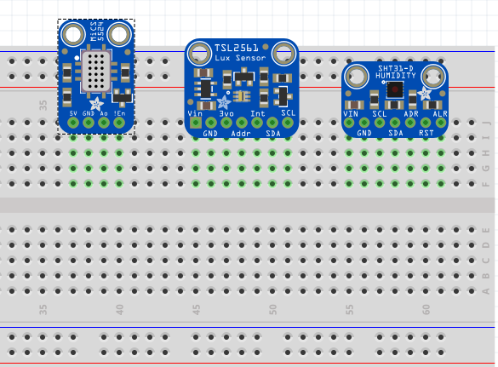
Begin by placing the Gas, Lux, and Humidity Sensors on the bread board as shown.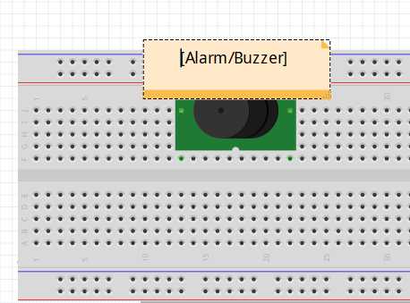
The buzzer is smaller the shown. It is also attached to the same breadboard.
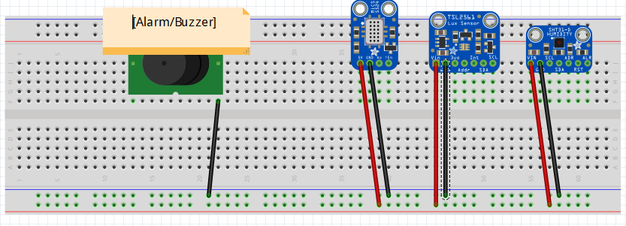
Attach wires from sensors to power and ground.
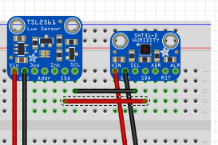
Connect the SDA and SCL pins of the Lux and Humidity sensor.

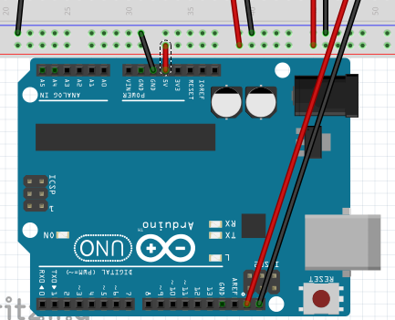
Connect ground pins on the breadboard to ground on the Arduino. Connect the 5V power from the Arduino to the power pins on the breadboard. Connect SDA and SCL from breadboard to Arduino.
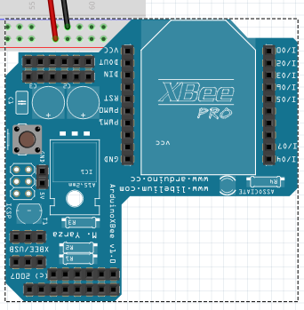
The ArduinoXbee shield will be attached on top of the arduino and the xbee itself will be attached on top of the shield. Because the shield covers some of the pins needed from the arduino those pins will instead be attached to the XBee shield.
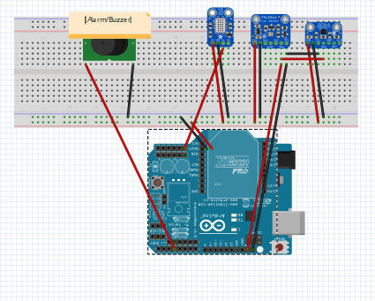

After connecting the buzzer to Digital pin 3~ and the gas sensor AO to pin A0 the hardware will be complete.

The mobile application requires the usage of Android 6.0 as a minimum, as well as build tools 25.0.0 and beyond.
Database

The system requires one database divided into two parts, one will be used to store the users that have signed up to use the mobile application and another to store all the gathered data from the room. The mobile application user’s database is a MySQL database on Apache server; its main purpose is to store the information of users that sign up for the application. This information consists a username and an encrypted password which will allow the user enter the mobile application. The second database, will be used to receive data from the hardware while it is observing the room. This data will be stored in the database which can be retrieved by the mobile application to display all the data gathered to the user. Both databases are still in development.

Build Instructions

The Database holds the users login information along with each users retrieved data sent from the Raspberry Pi. To make the database specific to our system follow these steps.

Setting Up Apache Server with PHP, MySQL and PHPMyadmin
- Download the latest Apache Version from the official Website https://www.apachelounge.com/download/ (this is a Zip-File)
- Copy Apache24 folder from Zip-File to your C: Drive
- Navigate into C:/Apache24/bin
-Open file --httpd-- with Rightclick -- Run as Administrator
- Open Start-menu -- Type in : cmd -- Right Click -- Run as Administrator
-Type in CMD ---- cd /Apache24/bin
- Type in -- httpd -k install -- leave CMD open
-Download !!THREAD SAFE!! Version of PHP from :http://windows.php.net/download#php-7.0
-Open PHP Zip-File
-Create folder --PHP-- in the C: Drive
-Copy Content of PHP Zip-File to C:/PHP/
- Go to C:/PHP
-Search for File with name: "php7apache2_4.dll" and copy the name
-Go to C:/Apache24/conf
-Open File "httpd" with Editor
- Scroll to bottom and add the following Code:
" LoadModule php7_module "C:/PHP/php7apache2_4"
AddHandler application/x-httpd-php .php
PHPIniDir C:/PHP "
- Search for line " DirectoryIndex index.html " Change to: "DirectoryIndex index.php index.html"
- Save and close
- Go back to CMD and type in " httpd -k restart "
- Download MySQL from : http://dev.mysql.com/downloads/window...
- Install MySQL with downloaded installer "Developer Default"
- During Installation choose ROOT Password and save it for later use
- Download phpMyAdmin from : https://www.phpmyadmin.net/
- Copy Folder in Zip File into C:/Apache24/htdocs
- Rename copied folder into "phpmyadmin"
- Navigate to C:/PHP
- Rename File "php.ini-production" to "php.ini"
- Open php.ini with Editor
- Search for Line "extension=php_mbstring.dll"
- Remove Semicolon ";" in front of "extension=php_mbstring.dll" and "extension=php_mysqli.dll"
-Save Exit - Open CMD and Type in " httpd -k restart "
Alternatively, you can utilize hostinger at www.hostinger.com. Here you just have to sign up and you will have apache, mysql and phpMyadmin at your disposal.

2.5.4 PCB and Soldering

2.5.5 Power Up

2.5.6 Unit Testing

2.5.7 Production Testing

2.6 Problems Encountered

2.6.1 PCB
There are several problems one might come across when building this project. One of the main issues will be soldering the PCBs. The original version of the PCBs are very difficult to solder due to the very little amount of space given between the soldering spots and the copper.

2.6.2 Xbee
Another issue may be the connection of our model of Xbees. Since the Xbees used are series 1 and have a little less functionality than the newer models, the initial setup of the xbees can be difficult and very tedious.

2.6.3 Data Descrepency
Another small issue that may vary for each user is the descrepency of the temperature data. Depending on where you store the device, the data being sent from the sensor hub can be skewed. This becomes apparent when the location at which you store the hub is more insulated than others. An example of this is if the user puts the hub inside the wall that is insulated more than the outer wall. There will be two very different results.

2.7 Aproaches to the Problems

2.7.1 PCB
To resolve the problem of soldering the pcb, the pcb can be remade to utilize the space on it. Since the pcb has a lot of unused copper, the connections between the components can be spread out more.

2.7.2 Xbee Setup
To resolve the issue of the Xbee setup, the user can get newer models to make it simpler to set up. The S1 version is older and takes more to initialize.

2.7.3 Data Descrepency
To manage the data descrepency, the user would need to put the hub in a visible area, or have multiple hubs residing in each room. This is an issue if the user wants an out-of-sight solution, but it is a fix for it.

3. Progress Reports

3.1 Report 1
Active House Progress Report

Our hardware is present every week
Recent and Current Progress
Vishwas Progress
He is working on connecting Arduino and Raspberry Pi through Xbee and soldering sensor hat

Oliver’s Progress
The mobile app needs to be redone for utilizing the php database but otherwise, the application is complete

Kyle’s Progress
Has downloaded apache web server and did some configurations, also set up php

Problems and Hyperlinks
- A problem we encountered so far is some complications with sothering, hence we had to buy an Xbee dongle.
https://github.com/kylesyCENG317/Active-House-

3.2 Report 2
Dear Austin Tian,
The Active House project has been behind these last few weeks. The group has further pushed to catch up. As the database has been a major point of concern, there has been more focus to get it set up, and as such, it has at the least been partially set up. There are still issues within each component, but they are being smoothened out.

For the hardware component, there has been a problem with reading data wirelessly between Xbees. The issue prevents further progression on the hardware component as since it does not allow data flow, it will not be able to proceed with database synchronization. Apart from this, Vishwas Malhotra is still working diligently to resolve the issue at hand.

For the application component, the only proceeding issue is not having a fully functional database to allow for data pulling. The application is meant to be a display app, thus without the data, it is unable to do what is needed of it. Extra quality of life features are pending, and can not be thoroughly tested until data has been received. These include metric to imperial conversions, as well as gas and temperature safety services to detect high levels of CO and heat. In its current state, the application is otherwise complete.

For the database component, the database has had its initial setup complete. With the use of phpmyadmin and Apache, a web server has been setup. There have been several issues that came up from initial setups such as a "missing mbstring extension", but this has been overcome and proceedings with the database is currently underway by Kyle Sy. This database is being hosted locally on a laptop. It needs further testing to see if it will allow external devices to access it.
Integration of all three components has not been fully completed. The application is slowly being integrated with the database. When it is fully set up, the database and app can synchronize. The hardware is unable to be integrated until data flow wirelessly is completed and the ability to send data to the database is established.

Other problems that have occurred is the lack of soldering of the few components that require it. When the Xbee link has been set up, it will be a priority to adjust and complete the soldering of the PCBs.

Financial Update: This project has increased in price by a total of $25.00. This pushes the total value from $308.00 to $333.00. It is an optional choice to do this, as it is to remove one of the soldering components. The component purchased was the Xbee Explorer USB Dongle, which allows communication between Xbees.

Thanks,
Oliver Duarte
(Student B)

3.3 Report 3

4. Conclusions
To conclude, the Active House project is a lengthy, but rather useful project. This is due to there being little to no alternatives in regards to what this project provides. As a home monitoring system, there is no other that can accomplish what this does. Due to the price of this project being quite high, it is not necessarily ready for commercial production. The price can be reduced by using cheap microcontrollers to handle the data flow from the sensors. This in itself can reduce the price of the project by approximately $100. It has been a learning experience to create this Active House project and has helped us learn to handle group work. It is a stepping stone to bigger and better projects.

5. Recommendations

6. Technical References

7. Appendicies

7.1 Arduino Uno Sensor Setup

7.2 Arduino Xbee link

7.3 Database Code

7.4 Mobile Application

7.4.1 Main Activity

7.4.2 RoomActivity

7.4.3 RoomViewActivity

7.4.4 HomeActivity

7.4.5 Register Activity

